
INSTITUTE OF TECHNOLOGY
SCHOOL OF COMPUTING
DEPARTMENT OF SOFTWARE ENGINEERING
COURSE CODE: Seng5127
COURSE NAME: WEB SERVICE
INDIVIDUAL ASSIGNMENT
SOAP WEB SERVICE (SHAPETOOL)
Name: SULEYMAN ABDU ID: 147312

Submitted to: Instructor Demeke G.
April 15, 2026
Woldia, Ethiopia

ShapeTool SOAP Web Service Documentation
1. Project Overview
ShapeTool is a fully functional SOAP-based web service developed to calculate the area of different geometric shapes such as circles, squares, rectangles, parallelograms, and triangles.
The entire project was built using a contract-first development approach. This means the XML Schema (XSD) was carefully designed first to define the precise structure of all requests and responses. From this schema, the WSDL contract was automatically generated, and the Java implementation was built on top of it.
This project serves as an excellent demonstration of enterprise-grade SOAP web service development. It showcases key concepts including SOAP messaging, strict XML validation, WSDL contract definition, request handling, and proper error management through SOAP Faults.
The service currently provides five independent operations:
- circleArea
- squareArea
- rectangleArea
- parallelogramArea
- triangleArea
Each operation is designed to accept only the parameters relevant to its specific shape and returns a clean, structured SOAP response containing the calculated area value.

2. Project Objectives
The main objectives of developing the ShapeTool SOAP web service are as follows:
- To design and implement a SOAP web service using the contract-first methodology.
- To create well-defined request and response message structures using XML Schema (XSD).
- To automatically expose a complete and standards-compliant WSDL contract.
- To implement the business logic using Spring Boot and Spring Web Services.
- To enforce strong input validation directly at the schema level.
- To handle errors professionally by returning structured SOAP Fault messages.
- To test the service comprehensively using SoapUI.
- To provide clear, detailed documentation along with sample request and response messages.

3. Technologies Used
This project leverages the following modern and widely used technologies:
- Java 21
- Spring Boot
- Spring Web Services (Spring-WS)
- JAXB for XML marshalling and unmarshalling
- XML Schema Definition (XSD)
- WSDL 1.1
- SoapUI for functional and integration testing

4. Design Approach
4.1 Contract-First Development
The ShapeTool service was developed following the contract-first approach. In this methodology, the service contract is created and finalized before any implementation code is written. The contract includes the XSD schema and the resulting WSDL file.
Major Benefits of Contract-First Approach:
- Provides a clear and stable service definition from the very beginning
- Makes integration with various clients much easier and more reliable
- Ensures excellent interoperability across different platforms and programming languages
- Enables strong schema-based validation of all incoming requests
- Simplifies testing, documentation, and future maintenance
5. Namespace Design
Service Namespace: http://www.shapetool.com/gen
Namespaces play a critical role in XML-based web services. They are used to uniquely identify the elements and types defined in this service, preventing any possible naming conflicts with other systems or services.
Using a dedicated namespace also improves clarity, ensures consistency across all components, and makes the service contract more maintainable when multiple services or versions exist in the same environment.

6. XSD Schema Structure
The foundation of the service contract is the XML Schema file named shapes.xsd. This schema defines the complete structure for all requests and responses used by the service.
Request Elements:
- circleAreaRequest
- squareAreaRequest
- rectangleAreaRequest
- parallelogramAreaRequest
- triangleAreaRequest
Response Elements:
- circleAreaResponse
- squareAreaResponse
- rectangleAreaResponse
- parallelogramAreaResponse
- triangleAreaResponse
Data Types and Restrictions: All area and input values are defined as xs:double. Additionally, a custom restriction is applied to ensure that all numeric inputs must be zero or positive numbers. This prevents invalid data such as negative values from entering the system.
The schema acts as the first line of defense by automatically rejecting any malformed or invalid messages before they reach the business logic.

7. Service Operations
The ShapeTool service exposes the following five operations, each tailored to a specific geometric shape:
circleArea Formula: Area = π × radius² Input: radius Output: area
squareArea Formula: Area = side × side Input: side Output: area
rectangleArea Formula: Area = length × width Input: length, width Output: area
parallelogramArea Formula: Area = base × height Input: base, height Output: area
triangleArea Formula: Area = 0.5 × base × height Input: base, height Output: area
Each operation is independent, accepts only the necessary parameters, and returns the computed area in a standardized response format.

8. WSDL Description
The Web Services Description Language (WSDL) file fully describes the ShapeTool service contract. It includes detailed information about all available operations, input and output messages, SOAP binding style, and the service endpoint.
- WSDL URL: http://localhost:8080/ws/shapes.wsdl
- Service Endpoint URL: http://localhost:8080/ws
Clients can use this WSDL to automatically generate client code or to understand exactly how to interact with the service.

9. How the SOAP Web Service Works with Spring Boot
The ShapeTool service is built on Spring Boot combined with Spring Web Services. Below is a detailed step-by-step explanation of how a typical SOAP request is processed:
- Client Sends SOAP Request A client application or tool (such as SoapUI) sends an HTTP POST request containing a SOAP envelope to the endpoint http://localhost:8080/ws.
- Request Interception by Spring The Spring framework’s MessageDispatcherServlet receives the incoming request and treats it as a SOAP message.
- Automatic Schema Validation Spring Web Services validates the incoming XML payload against the shapes.xsd schema. Any violation (wrong structure, missing fields, negative values, etc.) is immediately rejected.
- Payload Routing Based on the root element of the request (for example, circleAreaRequest), Spring-WS routes the message to the correct method in the @Endpoint class using the @PayloadRoot annotation.
- JAXB Unmarshalling The XML content is automatically converted into corresponding Java objects using JAXB marshalling configuration.
- Business Logic Execution The endpoint method performs the area calculation using the appropriate mathematical formula. The logic is kept clean and focused.
- Response Object Creation The calculated area is wrapped into the corresponding response object (e.g., CircleAreaResponse).
- JAXB Marshalling The Java response object is converted back into well-formed XML.
- SOAP Response Returned The final SOAP envelope is sent back to the client with HTTP status 200 (OK).
Error Handling Flow: If any validation fails or an exception occurs during processing, Spring Web Services automatically generates a structured SOAP Fault response. This ensures the client receives clear and standardized error information instead of a generic server error.
This architecture provides clean separation of concerns, excellent performance, and full compliance with SOAP standards.

10. Validation Strategy
Validation in ShapeTool is performed at multiple layers to ensure maximum reliability:
- Schema-level validation using XSD restrictions
- Required field checking
- Correct data type enforcement
- Business rule validation (non-negative values)
This strategy guarantees that only valid and meaningful data reaches the calculation logic, resulting in predictable and secure behavior.

11. SOAP Fault Handling
The service is designed to handle errors gracefully. It returns proper SOAP Fault messages in cases such as:
- Missing required parameters
- Invalid numeric values
- Negative numbers (violating schema restrictions)
- Malformed XML requests
Instead of throwing generic exceptions, the service provides structured, client-friendly SOAP Faults that include fault code, fault string, and detailed information.

12. Testing
Comprehensive testing was carried out using SoapUI. The test suite covered:
- Requests with valid inputs
- Requests with invalid XML structure
- Requests containing negative values
- Requests with missing parameters
- Boundary value testing
Expected Outcomes:
- Valid requests return correct area calculations
- Invalid requests return appropriate SOAP Fault responses

13. Sample Requests and Responses
A collection of sample SOAP messages is available in the file samples/requests.xml. This file includes:
- Valid request and response examples for all operations
- Invalid request examples
- SOAP Fault response examples
These samples serve as a quick reference for developers and testers.

14. Project Structure
The project follows a clean and standard Maven/Gradle-based Spring Boot structure:
- src/main/java – Contains all Java source code (endpoints, configuration, etc.)
- src/main/resources/schemas/shapes.xsd – The main XML schema definition
- samples/requests.xml – Sample SOAP messages
- README.md – Project documentation

15. Design Decisions
Several important design decisions were made to improve clarity and maintainability:
- Each shape has its own dedicated operation for better readability and usability
- Strong validation rules are defined directly in the XSD schema
- Spring Boot is used to simplify setup, configuration, and deployment
- The contract-first approach ensures a stable and interoperable service contract

16. How to Run the Project
Follow these simple steps to run and test the ShapeTool service:
- Start the Spring Boot application (using Maven, Gradle, or directly from your IDE)
- Open a browser and navigate to the WSDL URL: http://localhost:8080/ws/shapes.wsdl
- Import the WSDL into SoapUI
- Create new requests and send them to the service
- Verify that the responses and fault messages are as expected
17. Conclusion
ShapeTool is a complete and well-structured SOAP web service that effectively demonstrates the power of contract-first development using Spring Boot and Spring Web Services.
It successfully implements area calculations for multiple geometric shapes, enforces strict validation, handles errors through proper SOAP Faults, and exposes a clean WSDL contract. The project fully meets its objectives and serves as a strong example of modern SOAP-based enterprise application development.

APPENDIX
Case 1 For nagative value
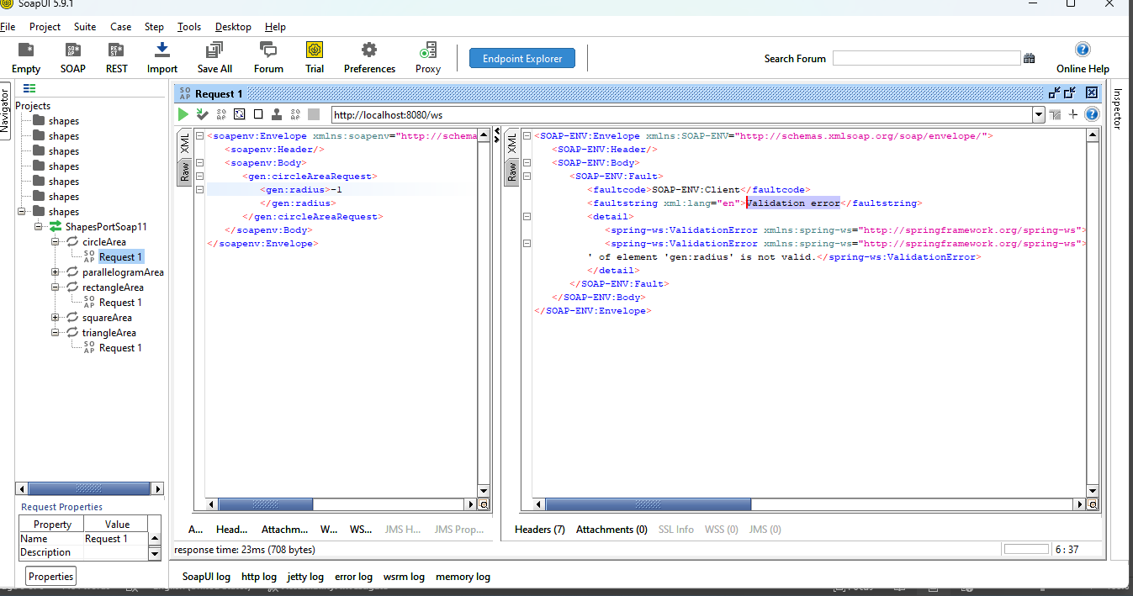

Case2: positive value
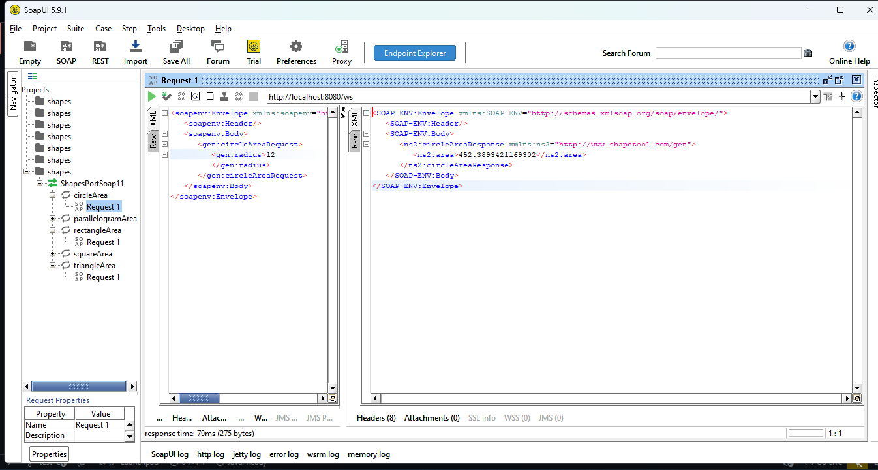

Case 3: 0 (zero) value
